LAB-09

Connect to a MongoDB server using MongoDB Compass.

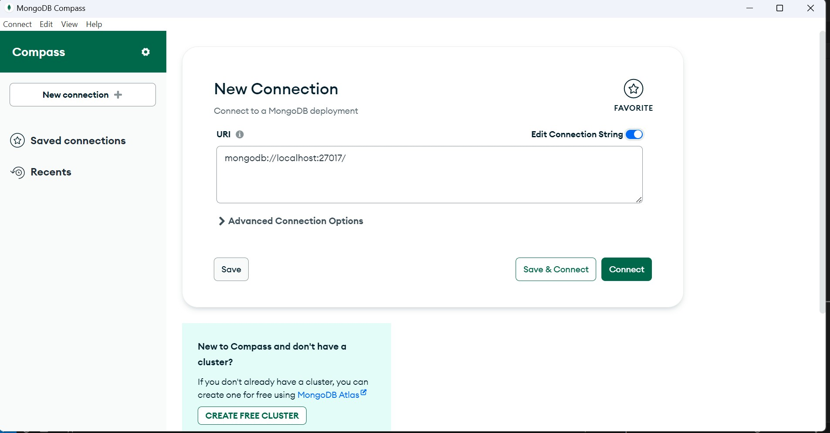

Create a new database named "testdb" in MongoDB Compass.

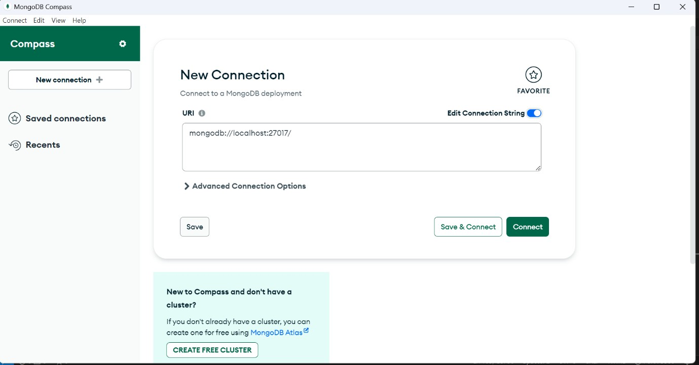

Create a new collection named "students" in the "testdb" database.

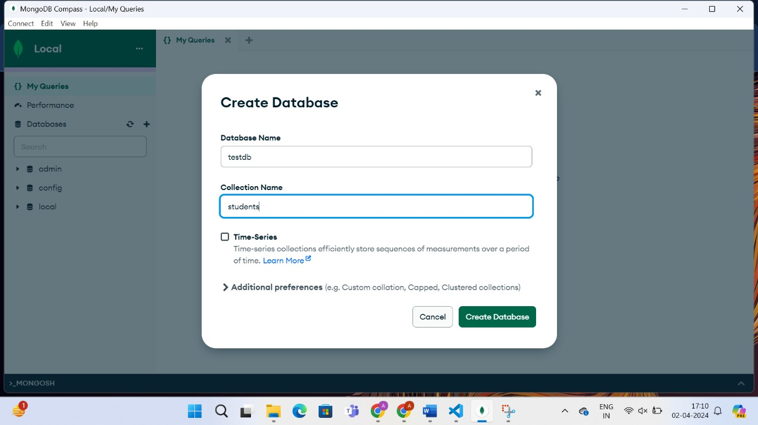

Insert ten documents into the "students" collection with the following fields: name, age, and email.

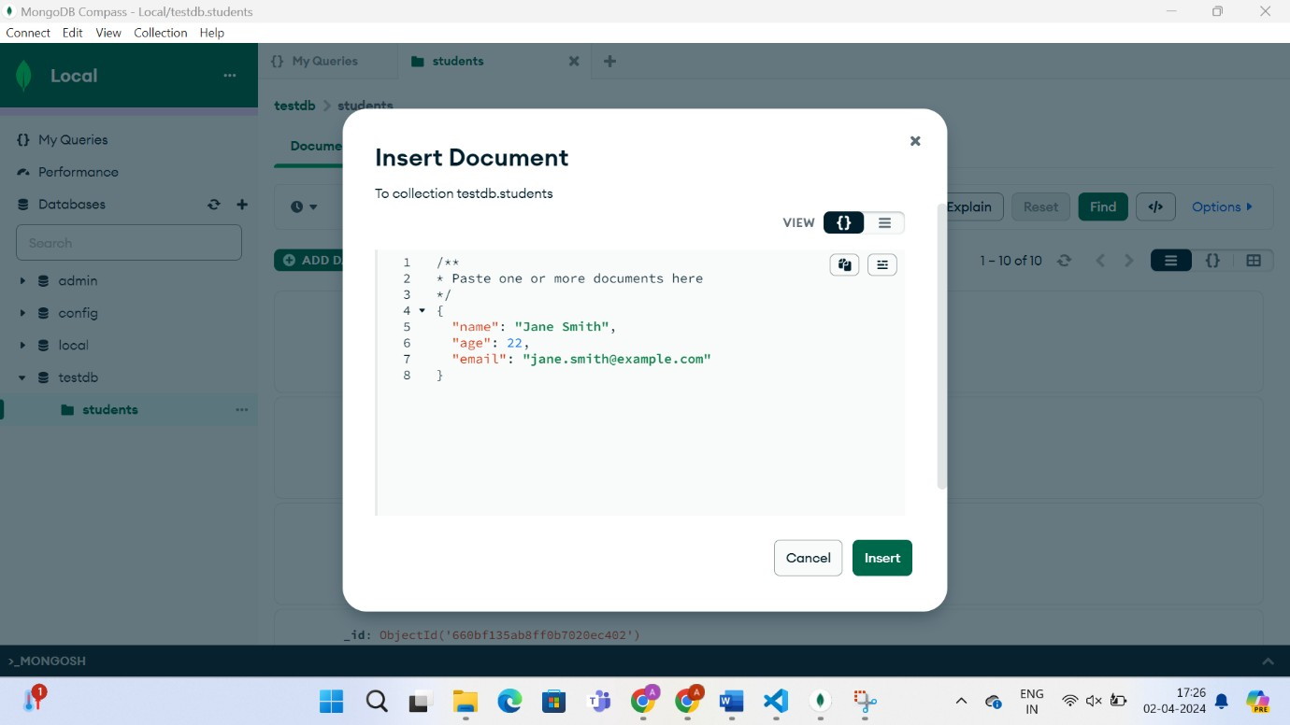

View the contents of the "students" collection.

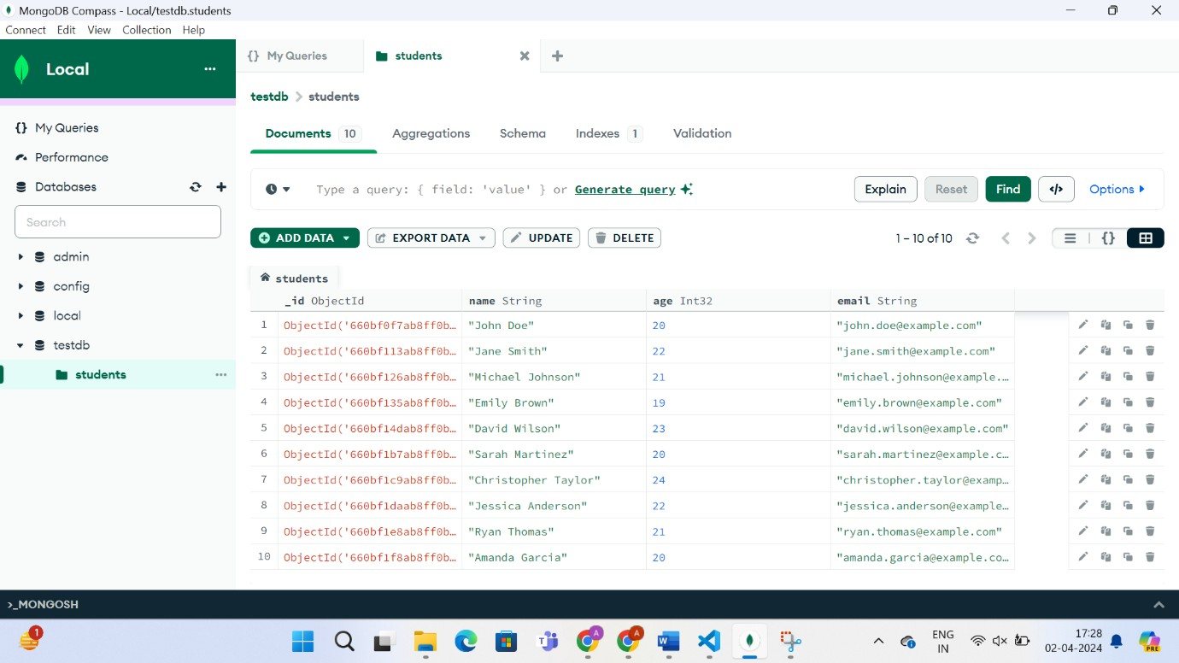

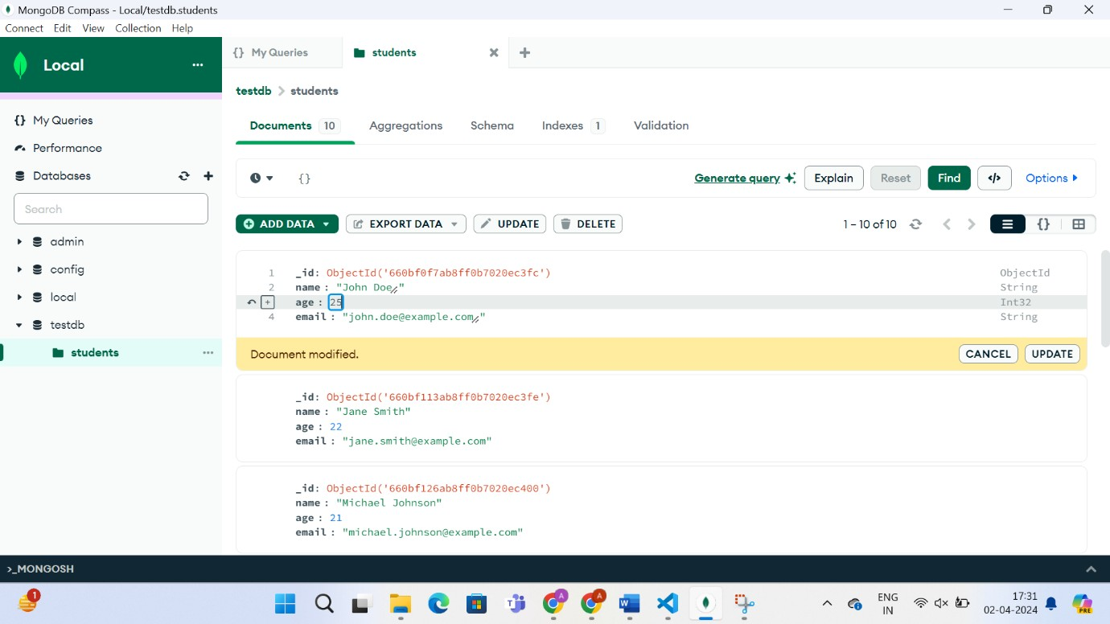Update the age of a specific student in the "students" collection.

Delete a document from the "students" collection based on a specific condition.

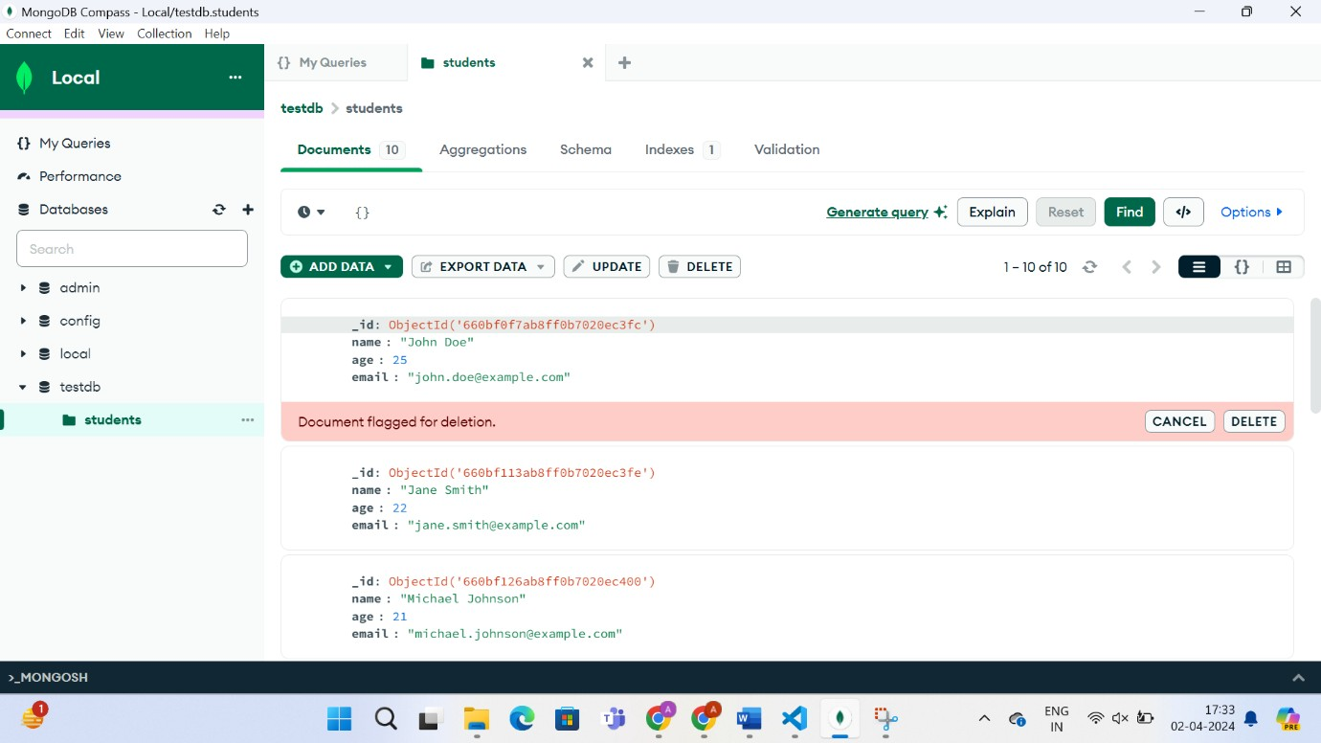

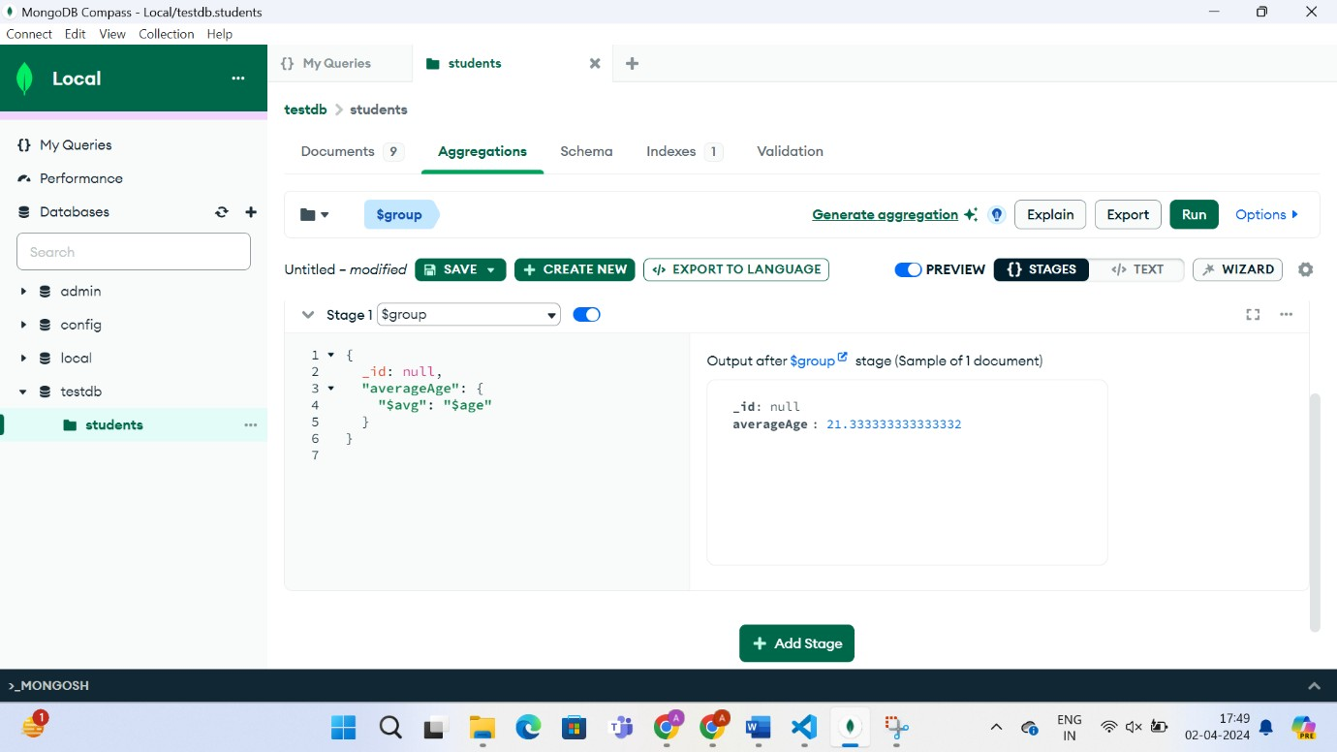Use the aggregation pipeline to calculate the average age of all students in the"students" collection.

Create an index on the "name" field in the "students" collection.

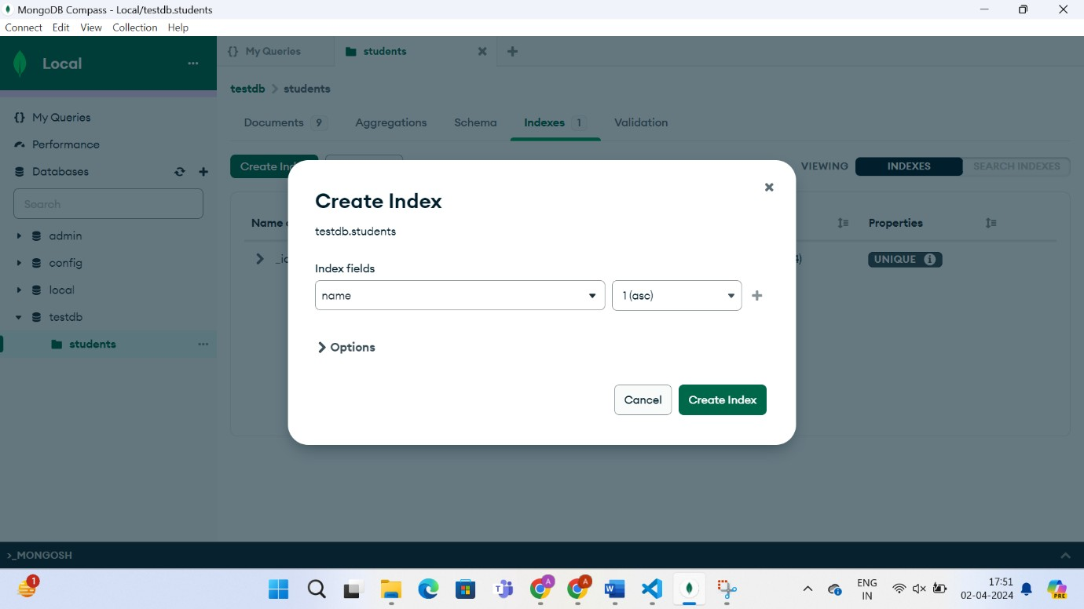

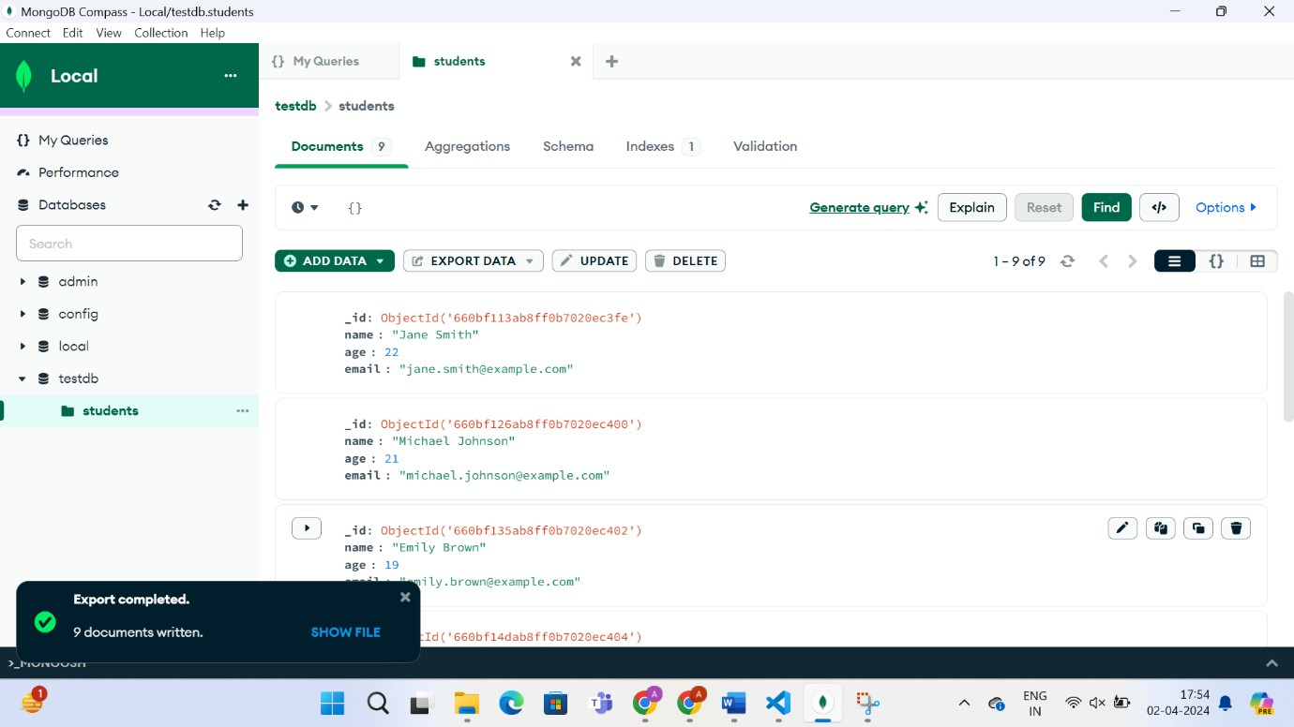Export the contents of the "students" collection to a JSON file.

Perform a complex aggregation operation to find the top 5 oldest students in the "students" collection.

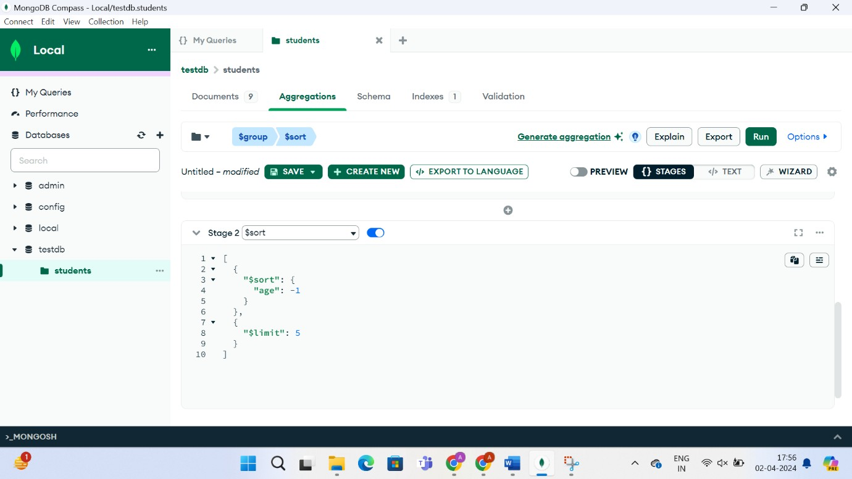

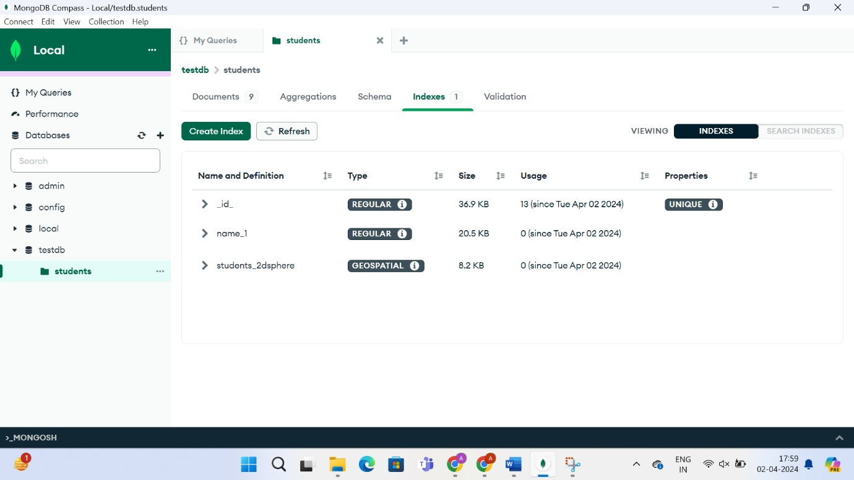Create a geospatial index on a field representing the location of students.